AN EFFICIENT NOVEL APPROACH FOR PREDICTING STARTUP COMPANY SUCCESS RATES USING ADVANCED MACHINE LEARNING PARADIGMS
Conclusion, Future Scope and References
Department of Computer Science and Engineering, [COLLEGE NAME]
Batch C10 (CSE-C) · Academic year [ACADEMIC YEAR]
Table 1: Project team
S.No. | Student name | Roll number
1 | Orchu Shirisha | 23K91A05H6
2 | Mudavath Raghavendar | 23K91A05G1
3 | Majgi Vaishnavi | 23K91A05E0
4 | Polishetty Poojitha | 23K91A05J4

Project guide: P Prasanna
Chapter and section numbers quoted in the text (for example Chapter 8 or Section 6.2) refer to the full project report, 17.Final Document. Figures and tables in this document are numbered from 1.

1. CONCLUSION

1.1 Summary
The project set out to predict, from historical startup data, whether an early-stage company is more likely to succeed or fail, to compare the standard classifiers on that task and to name the factors behind each prediction. The system was built and works end to end as VenturePulse: it accepts structured inputs and an optional description, returns a SUCCESS or FAILURE estimate with probabilities and a risk label, lists the main feature terms and shows the comparable historical startups that support the estimate.
The report measured the system honestly. The model that the application serves was trained on a 1,400-row synthetic fallback and scores 0.749 balanced accuracy on it; that number is a pipeline check. On the real public table of 922 startups, under five repeated 80/20 splits, Random Forest reaches a balanced accuracy of 0.746 ± 0.031 and a ROC-AUC of 0.816 ± 0.022, XGBoost 0.746 ± 0.026 and 0.806 ± 0.019, and Logistic Regression 0.709 ± 0.025 and 0.789 ± 0.017.

1.2 Objectives achieved
Table 2: The six objectives and what was achieved
No. | Objective | Outcome
1 | Collect a startup dataset | Partly: the real 922-row public table was obtained and analysed (funding, sector, location, outcome); team background is missing; the shipped app runs on a synthetic fallback of the same schema
2 | Clean the data and engineer features | Partly: cleaning, imputation, scaling, one-hot encoding and log funding done; funding velocity only approximated by ages and rounds; no team-experience or market-context feature exists
3 | Address class imbalance | Achieved: balanced class weights in the application and a comparison with oversampling on real data; no ROC-AUC gain, success is the majority class here
4 | Train and compare LR, DT, RF and boosting | Achieved: four models in the application and HistGradientBoosting in the study, under 5 x 80/20 splits
5 | Identify separating features | Achieved: Random Forest Gini and permutation importance and logistic-regression weights; relationships ranks first in both tree measures
6 | Evaluate with accuracy, precision, recall, F1, ROC-AUC | Achieved on real data; ROC-AUC of the shipped fused model was not recorded

1.3 Key findings
1. On real startups the tree ensembles rank above logistic regression (balanced accuracy 0.746 and 0.746 against 0.709), as the base paper claims, but at an accuracy of 0.775 and not at the 85-92 % it reports; Random Forest, XGBoost and HistGradientBoosting lie within one standard deviation of one another.
2. The table leaks: removing relationships, milestones and the two milestone-age fields lowers ROC-AUC from 0.816 to 0.719 for Random Forest and from 0.806 to 0.699 for XGBoost, and the ensembles lose their lead.
3. Retrieval alone is competitive: balanced top-k voting with no trained model reaches balanced accuracy 0.714 to 0.703 and ROC-AUC 0.769 to 0.789, equal to logistic regression, and the retrieved startups give a user something to inspect.
4. Imbalance handling changes recall, not ranking: class weights or oversampling leave ROC-AUC at about 0.816 and balanced accuracy at 0.75 for Random Forest; the logistic-regression balanced accuracy is flat between thresholds 0.30 and 0.50 (0.71) while recall of success falls from 0.88 to 0.67.
5. The text channel is untested on real startups: the real table has no descriptions, and the synthetic descriptions leak the class, so the 0.749 of the shipped fused model must not be read as real-world performance.
6. The software is sound: 51 automated checks pass and a prediction takes a median of 148 to 198 ms on a CPU.

1.4 Practical applications
• A screening aid that gives a first, evidence-backed view of a startup profile and shows which comparable companies and features drive it.
• A teaching and demonstration tool for a complete tabular machine-learning workflow: imbalance, model comparison, threshold choice, calibration and leakage checks.
• A starting point for a team with its own labelled startup data and time stamps, where the same pipeline can be retrained and validated out of time.
• It is not investment advice and not a replacement for due diligence.

1.5 Known limitations
The main limitations are the synthetic training data of the served model (L1), the leakage-like fields (L2), the lack of a temporal split (L3), the small single-country table with 185-row test folds (L4), the untested text channel (L5), the missing founder and market data (L6) and uncalibrated probabilities (L8). The full list L1 to L10 is given in the document on scope and limitations.
The model comparison on the real table and the position against the published figures behind the key findings are shown below.
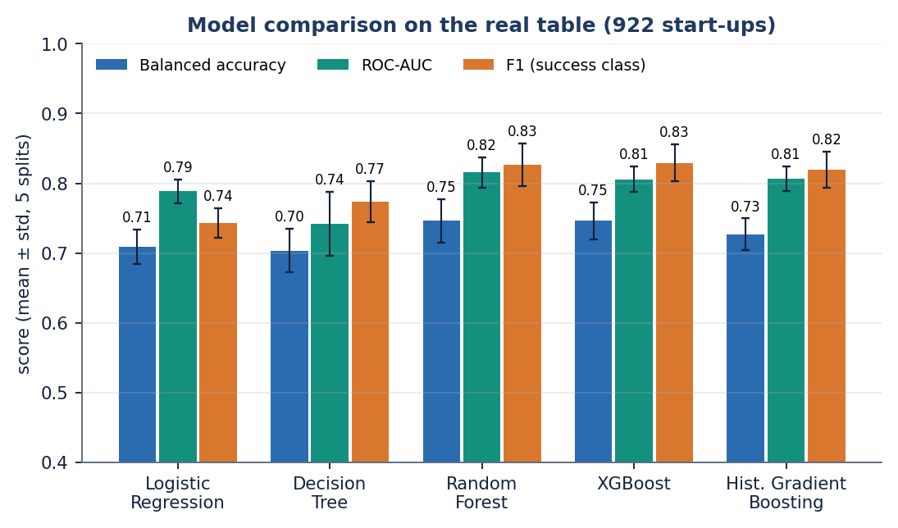
Figure 1: Balanced accuracy, ROC-AUC and F1 of the five models on the real 922-row table (5 x 80/20 splits).
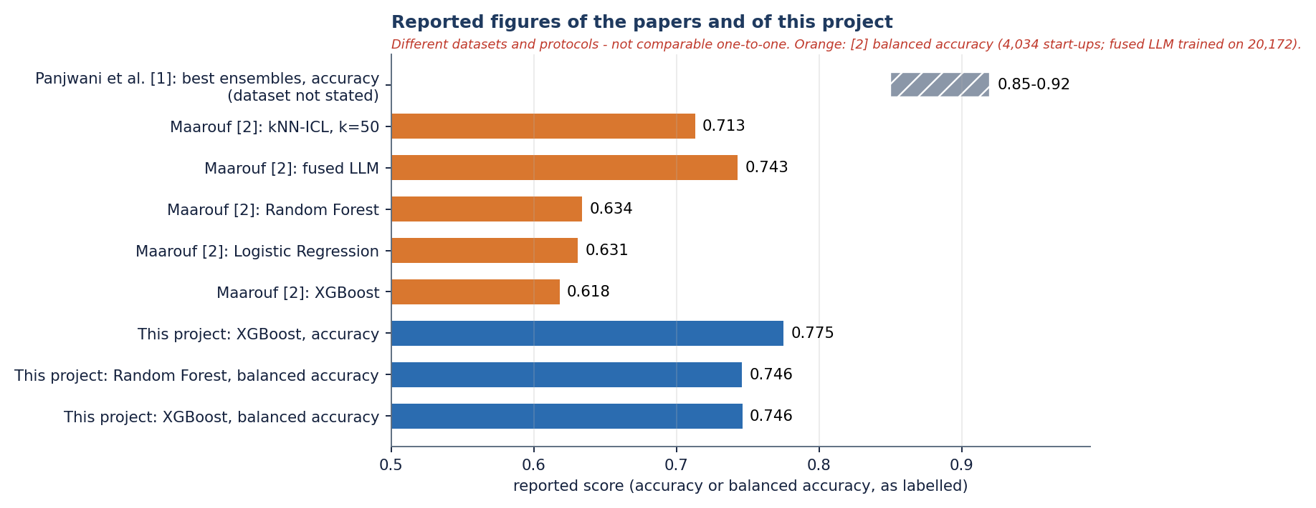
Figure 2: Published figures and this project's real-table figures; the datasets differ, so the bars are not directly comparable.

2. FUTURE SCOPE

2.1 Improvements to the model
1. Validate out of time: obtain founding and event dates, train on earlier cohorts and test on later ones, and drop fields recorded after the outcome window, as the reference study does with a leakage-safe temporal panel [3] (untested here).
2. Add the missing inputs: founder and team experience, team size and composition, and market context, which the abstract names and the base paper's features include [1] (no data yet).
3. Test the text channel on real startups: collect genuine company descriptions (for example from a public company directory under its licence) and measure the fused representation and retrieval against the structured baseline.
4. Calibrate the probabilities (Platt or isotonic scaling with class priors) and report Brier score and reliability curves, because the class-weighted logistic regression is visibly miscalibrated on real data (L8).
5. Add SHAP-based explanations for the tree ensembles [33] in place of coefficient and importance terms, and compare them with the Gini and permutation rankings.
6. Tune each model (grid or Bayesian search), tune alpha and k, and compare the served model choice with the study's best model; add significance tests over many more splits or repeated cross-validation.
7. Report PR-AUC next to ROC-AUC, as the reference study does [27, 3], and evaluate cost-sensitive decision thresholds chosen by an investor's own costs.

2.2 Improvements to the application
• Let the application select the served model from the real-data results and show its ROC-AUC on the Performance screen (L9).
• Warn the user when the inputs lie outside the range of the training data or when the confidence is low, and show the calibrated confidence.
• Accept a CSV of many startups and return a ranked list with downloadable results.
• Save each analysis (inputs, outcome, comparable startups) for later review, with a proper user store replacing the demo token.
• Show the retrieval evidence as a chart of outcomes among the nearest startups, per industry and funding stage.

2.3 Scalability and deployment
• Serve the backend with several worker processes behind a reverse proxy, add real authentication and rate limits, and store models and analyses in a database (L10).
• Cache the embedding of repeated descriptions and pre-compute the training-matrix similarity index (for example approximate nearest neighbours) so that retrieval stays fast with hundreds of thousands of startups.
• Run a load test and a memory profile; only sequential requests were timed here.
• Package the application as a container image (a Dockerfile exists but was not exercised in this report) for one-command deployment.

2.4 Further research
• Compare the retrieval-based approach with a language model that reads the retrieved startups, as in the method anchor [2], on the same data and protocol.
• Extend to richer outcome horizons (next funding, patenting, exit) as in the reference study, and to survival analysis for time-to-exit.
• Study fairness and bias across regions, sectors and founder groups, since a model trained on a US table may disadvantage other ecosystems.
• Run a user study with founders and investors on whether comparable-startup evidence and feature drivers change their decisions.

3. REFERENCES
[1] M. Panjwani, P. Shrivastava, P. Hande, G. Meshram, N. Verma and D. Gotmare, "Startup success prediction using machine learning and ensemble techniques," Int. J. Res. Appl. Sci. Eng. Technol. (IJRASET), vol. 14, no. IV, Apr. 2026, doi: 10.22214/ijraset.2026.80226.
[2] A. Maarouf, A. Bakiaj and S. Feuerriegel, "Predicting startup success using large language models: A novel in-context learning approach," arXiv:2601.16568, Jan. 2026.
[3] S. Mashhadi, A. Saghezchi and V. G. Kashani, "Interpretable machine learning for predicting startup funding, patenting, and exits," arXiv:2510.09465, 2026.
[4] A. Krishna, A. Agrawal and A. Choudhary, "Predicting the outcome of startups: Less failure, more success," Northwestern University, 2016.
[5] D. Camelo Martinez, "Startup success prediction in the Dutch startup ecosystem," M.S. thesis, Delft University of Technology, Delft, The Netherlands, 2019.
[6] H. B. G, A. Kumar and R. Kumar, "Startup success prediction using machine learning algorithms," JNNCE J. Eng. Manage., 2024.
[7] M. Razaghzadeh Bidgoli, I. Raeesi Vanani and M. Goodarzi, "Predicting the success of startups using a machine learning approach," J. Innov. Entrepreneurship, vol. 13, 2024.
[8] J. Li, "Prediction of the success of startup companies based on support vector machine and random forest," in Proc. Int. Workshop Artif. Intell. Educ. (WAIE), 2020.
[9] K. Zbikowski and P. Antosiuk, "A machine learning, bias-free approach for predicting business success using Crunchbase data," Inf. Process. Manage., vol. 58, no. 2, 2021.
[10] S. M. A. Jafari, A. M. Dehkordi and E. Chitsaz, "A quantitative meta-analysis of AI-based predictors for startup success," 2024.
[11] G. Ross, S. Das, D. Sciro and H. Raza, "CapitalVX: A machine learning model for startup selection and exit prediction," J. Finance Data Sci., vol. 7, pp. 94-114, 2021.
[12] S. Tomy and E. Pardede, "From uncertainties to successful start-ups: A data analytic approach to predict success in technological entrepreneurship," Sustainability, vol. 10, no. 3, 2018.
[13] Y. Choi, "Startup success prediction with PCA-enhanced machine learning models," J. Technol. Manage. Innov., vol. 19, no. 4, 2024.
[14] A. Maarouf, S. Feuerriegel and N. Prollochs, "A fused large language model for predicting startup success," Eur. J. Oper. Res., 2025.
[15] M. Bonaventura, V. Ciotti, P. Panzarasa, S. Liverani, L. Lacasa and V. Latora, "Predicting success in the worldwide start-up network," Sci. Rep., vol. 10, 2020.
[16] L. Gius, "Disagreement predicts startup success: Evidence from venture competitions," Strategy Sci., vol. 10, no. 2, pp. 93-108, Jun. 2025, doi: 10.1287/stsc.2024.0169.
[17] I. B. Bhandari, "Impact of venture capital on startup success and economic growth in Nepal," Nepalese J. Finance, vol. 12, no. 1, Jan. 2025.
[18] L. Breiman, "Random forests," Mach. Learn., vol. 45, no. 1, pp. 5-32, Oct. 2001.
[19] T. Chen and C. Guestrin, "XGBoost: A scalable tree boosting system," in Proc. 22nd ACM SIGKDD Int. Conf. Knowl. Discovery Data Mining, San Francisco, CA, USA, 2016, pp. 785-794.
[20] J. H. Friedman, "Greedy function approximation: A gradient boosting machine," Ann. Statist., vol. 29, no. 5, pp. 1189-1232, Oct. 2001.
[21] F. Pedregosa et al., "Scikit-learn: Machine learning in Python," J. Mach. Learn. Res., vol. 12, pp. 2825-2830, 2011.
[22] H. He and E. A. Garcia, "Learning from imbalanced data," IEEE Trans. Knowl. Data Eng., vol. 21, no. 9, pp. 1263-1284, Sep. 2009.
[23] N. V. Chawla, K. W. Bowyer, L. O. Hall and W. P. Kegelmeyer, "SMOTE: Synthetic minority over-sampling technique," J. Artif. Intell. Res., vol. 16, pp. 321-357, 2002.
[24] H. He, Y. Bai, E. A. Garcia and S. Li, "ADASYN: Adaptive synthetic sampling approach for imbalanced learning," in Proc. IEEE Int. Joint Conf. Neural Netw. (IJCNN), Hong Kong, 2008, pp. 1322-1328.
[25] N. Reimers and I. Gurevych, "Sentence-BERT: Sentence embeddings using Siamese BERT-networks," in Proc. Conf. Empirical Methods Natural Lang. Process. (EMNLP-IJCNLP), Hong Kong, 2019, pp. 3982-3992.
[26] W. Wang, F. Wei, L. Dong, H. Bao, N. Yang and M. Zhou, "MiniLM: Deep self-attention distillation for task-agnostic compression of pre-trained transformers," in Advances in Neural Information Processing Systems, vol. 33, 2020, pp. 5776-5788.
[27] T. Saito and M. Rehmsmeier, "The precision-recall plot is more informative than the ROC plot when evaluating binary classifiers on imbalanced datasets," PLoS ONE, vol. 10, no. 3, Art. no. e0118432, 2015.
[28] T. Fawcett, "An introduction to ROC analysis," Pattern Recognit. Lett., vol. 27, no. 8, pp. 861-874, Jun. 2006.
[29] S. Kaufman, S. Rosset, C. Perlich and O. Stitelman, "Leakage in data mining: Formulation, detection, and avoidance," ACM Trans. Knowl. Discovery Data, vol. 6, no. 4, Art. no. 15, 2012.
[30] T. Cover and P. Hart, "Nearest neighbor pattern classification," IEEE Trans. Inf. Theory, vol. 13, no. 1, pp. 21-27, Jan. 1967.
[31] T. B. Brown et al., "Language models are few-shot learners," in Advances in Neural Information Processing Systems, vol. 33, 2020, pp. 1877-1901.
[32] M. KC, "Startup success prediction," Kaggle dataset (public domain), https://www.kaggle.com/datasets/manishkc06/startup-success-prediction.
[33] S. M. Lundberg and S.-I. Lee, "A unified approach to interpreting model predictions," in Advances in Neural Information Processing Systems, vol. 30, 2017, pp. 4765-4774.
[34] "Impact of venture capital on startup success rates across industry: An empirical study," Eur. Econ. Lett., 2024. [Listed in the batch literature survey; authors not verified.]
[35] "The role and impact of SICTIC in the Swiss startup ecosystem," book chapter, 2026. [Listed in the batch literature survey; authors and publisher not verified.]

